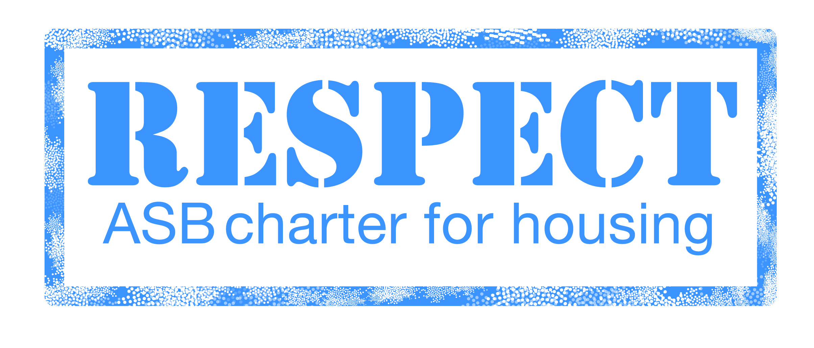

SUMMARY OF OUR ANTISOCIAL BEHAVIOUR POLICY

1. POLICY STATEMENT

Partners are committed to ensuring that all residents enjoy their right to peace, quiet, and security in and around their homes. We recognise that antisocial behaviour can have a severe effect on the well being of residents and that we have a duty to take action to minimise it. We will use all of the available tools and powers to prevent anti-social behaviour from happening in the first place and to take action to stop it.

We recognise that the causes and effects of ASB can be wide ranging and can impact on all areas of the community and are not just restricted to our tenants. To address this we will look to work in Partnership to ensure that all available measures are applied effectively to tackle reported issues of ASB regardless of who owns the property. Our partners include

- Police
- Islington Council Services
  - Environmental and Regeneration
  - Housing and Adult Social Services
  - Children’s Services
- Fire Service
- Court Witness Service / ASB Support
- Primary Care Trust
- All other Social Landlords

This policy serves to provide a clear outline of our on-going commitment to dealing with anti-social behaviour and delivery of a quality and effective housing service.
Islington Housing’s policy highlights the following key values in dealing with anti-social behaviour:

- Defining what is unacceptable behaviour for all residents
- Encouraging a self-help approach where appropriate
- Set realistic expectations of what Islington Housing can deliver
- Work with community and partners to deliver effective solutions
- Recognising and implementing best practice
- Value diversity and respect for all
- Take swift and appropriate action both supportive and enforcement
- Keeping reporters of ASB and the community informed of action taken

2. DEFINITION OF ANTISOCIAL BEHAVIOUR

There is no definitive definition as to what antisocial behaviour is. Partners have aligned with Islington Council Housing’s definition who have produced and work to the following definition:

The term anti-social behaviour includes all types of behaviour, which adversely affects the quality of life of local people. It is the bad behaviour of a few that seriously affects those around them who experience it.

Anti-social behaviour is defined in the ASB Crime and Policing Act 2014 as:

- Conduct that has caused, or is likely to cause, harassment, alarm or distress to any person
- Conduct capable of causing nuisance or annoyance to a person in relation to that person’s occupation of residential premises, or
- Conduct capable of causing housing related nuisance or annoyance to any person

There are many types of behaviour, which can be considered as antisocial, examples of these include noise nuisance, graffiti, litter, vandalism, harassment, and drug and alcohol misuse.

3. SERVICE COMMITMENT / STANDARDS

Partners take all reports about anti-social behaviour seriously. We are determined to reduce anti-social behaviour using all the available tools and powers to achieve this.

Our service commitment to you when dealing with Anti-Social behaviour is:

- We will take all reports of ASB and harassment seriously whether made in person, in writing or over the phone

- If you report ASB or harassment then we will make an appointment to carry out an interview, if necessary within, five working days or 24 hours in serious cases

- We will take appropriate action against those responsible, where we have evidence

- We will review all reported cases of ASB at least once a month and inform you of progress. If we decide to close a case we will write to you and tell you why

- We will provide on-going support for as long as victims feel it is necessary and as long as reasonably practical

- Please remember that the action we take must be reasonable in light of how serious the problem is and it has to stand a fair chance of working.

We may not be able to take any legal action if we have insufficient evidence to support the action at court

4. REPORTING ASB

There are several options available to allow you to report antisocial behaviour to us.

Reports can be made in person at any of our area housing offices, or by telephone, letter or email.

Antisocial behaviour can be reported to the Partners office by using the following methods of contact:

- In person
- By telephone: 0800 587 3595/020 7288 8310
- By email: asbt@partnersislington.net
- In writing: Partners For Improvement In Islington
FREEPOST NATE1235
London
N1 8BR
- On line reporting: www.partnersislington.net

All of our officers have received accredited training in how to deal with reports of anti-social behaviour.

If the report involves any sort of criminal activity, you should also notify the police on 101 or in cases of emergency 999.

When a report of anti-social behaviour is received we will look to undertake the following:

With the reporter

- Conduct an interview with the victim
- Ensure the victim is aware of our commitment to dealing with their report
- Outline limitations and set expectations for the reporter
- Agree an action plan for managing their reported case
- Advise the victim of any appropriate or available support services
- Provide an individually tailored support pack of relevant information
- Undertake a risk assessment of the reporter to determine any vulnerability or risk factors
- Identify and arrange interviews with any witnesses to support the case
- Agree a suitable time period and process for updating the reporter as to the progress of the case
- Confirm confidentiality unless the reporter is agreeable for any disclosure

The alleged perpetrator

- Arrange interview with the alleged perpetrator
- Identify any support or interventions that may be available to the individual or their family such as family intervention projects and refer as appropriate
- Undertake a risk assessment to determine any vulnerability or risk factors
- For young people look to provide access to diversionary and support mechanisms such as Targeted Youth Support, Positive Futures and acceptable behaviour contracts

5. TOOLS WE WILL USE TO ADDRESS ANTISOCIAL BEHAVIOUR

Partners have a dedicated ASB team that manage reported cases of ASB. The team consists of a Team Leader, 4 ASB Officers and a Housing Services Administrator.

The approach adopted in combating ASB is one that involves the use of a variety of tools and attempts to resolve the ASB with the use of appropriate support services and mediation.

A key objective of addressing anti-social behaviour is that of looking to challenge the unacceptable behaviour of an individual(s) and bring about identifiable changes, without recourse to legal action wherever possible. If perpetrators can be deterred or prevented from acting antisocially it is preferable in comparison to facing the possible consequences of their behaviour.

Opportunities and preventative action to limit and minimise antisocial behaviour will be taken whenever and wherever they are identified.
Legal action is only taken where necessary and proportionate, and in cases involving serious/persistent breaches of tenancy. Eviction is only sought as a last resort.

Officers have an array of tools at their disposal for combating antisocial behaviour in partnership with other agencies. The action we can take will be specific and exclusive to each case. A summary of the tools available is as follows:

Pre-Legal Action

- Acceptable behaviour contract
- Mediation
- Family Intervention Projects
- Noise Monitoring Machines
- Introductory Tenancies
- Restorative Justice
- Parenting contracts
- Referrals to Targeted Youth Support
- Housing Support and Supporting People

Legal Tools

- Civil Injunction
- Absolute grounds for possession
- Possession Proceedings

With Partners

- ASB Support Service
- Designated Public Place Orders
- Dispersal Orders
- Criminal Behaviour Order
- Closure Powers
- Demotion Orders
- Fixed Penalty Notices
- Community Protection Notices
- Noise Abatement Notices

These represent a summary of some of the tools and powers available to us.

We will look to employ all tools and powers at our disposal to ensure the appropriate action is taken for your case. We will maintain regular feedback with yourself and advise you when we decide to close your case.

Where perpetrators of ASB show a willingness to address the underlying causes of their behaviour we will offer them assistance and support in this.

When approaching alleged perpetrators we will always give consideration to issues of vulnerability (e.g. If there are disability problems, if there are mental health problems, family and peer issues, where there are drug/alcohol abuse problems, involvement with gangs etc.) Young people and elderly people may also be considered to be vulnerable because of their age or home and family circumstances.

Where such problems exist we will seek the intervention and support of other partner agencies to assist in addressing the problem behaviour.

