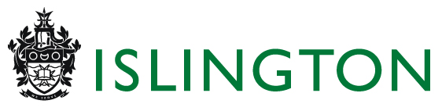


PAYING RENT ARREARS BY MONTHLY DIRECT DEBIT

If you have decided to pay your rent by Direct Debit you can also elect to have an additional amount collected from your bank account each month to reduce any arrears until they are cleared.

The monthly equivalent amount (as shown below) will be added to the monthly rent due and the total amount debited from your bank/building society account.

You will be notified in advance of the total amount and dates prior to the first payment.
----------------------------------------------------------------------------------------------------------------------------------------------------------------------------------------------------------------------------------------------------------------------------------------

Please complete and return this form with your Direct Debit Instruction.

Name:
Address:

Rent Account No.

NB You must consult your Income Recovery Officer if you already have, or wish to make, an arrangement to pay off rent arrears before you complete this form.

I would like to pay: (✓ the box) in addition to the monthly rent.

- £16.03 per month [£3.70 per week]
- £21.66 per month [£5 per week]
- £43.33 per month [£10 per week]
- £65 per month [£15 per week]
- £_________ per month (min. £16.03)

Please note that as the above amounts form part of your Direct Debit you are covered by the Direct Debit Guarantee so should any mistake be made by the Council or your bank you will be entitled to a full refund of the amount taken from your account in error.

The payment by you of any amount in addition to your monthly rent as part of the Direct Debit payment will not alter any agreement you may have reached with Islington Council as to any arrears on your rent account or in any way be deemed to amount to a concession by Islington Council in respect of any Court Order which may be in existence as to such arrears.

Please debit the above amount (as indicated) in addition to the monthly rent from my bank/building society account. This extra amount has been agreed with my Income Recovery Officer

Signature(s) Date

If you have any rent arrears you should contact your Income Recovery Officer who will advise you about Housing Benefit and may also be able to arrange for you to clear your arrears by instalments; If you do not the Council may still take action against you.

Please return this form with your Direct Debit Instruction to : (no stamp required)
Islington Council
Freepost RTHU-RRTZ-XRLS
Income Control DD
Northway House
257 Upper Streeet
LONDON
N1 1RU

ddars52 1999 rev 2014

